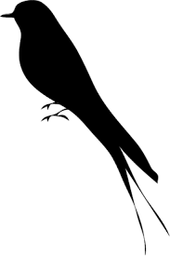
#1
Scottsboro Mockingbird

#2
Scottsboro Mockingbird

#3
Scottsboro Mockingbird

#4
Scottsboro Mockingbird

