People Involved
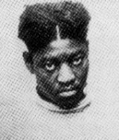  Haywood Patterson | Role in trial:______________________________  Background: _____________________________  Personality:______________________________  Actions: _________________________________  _________________________________________ | Similar to:  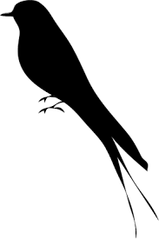
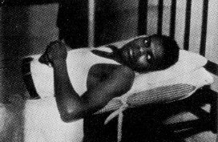  Ozie Powell | Role in trial:______________________________  Background: _____________________________  Personality:______________________________  Actions: _________________________________  _________________________________________ | Similar to:
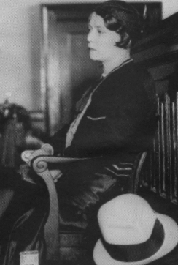  Victoria Price | Role in trial:______________________________  Background: _____________________________  Personality:______________________________  Actions: _________________________________  _________________________________________ | Similar to:
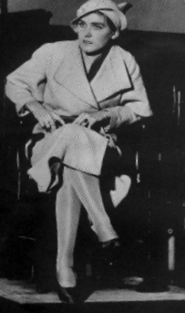  Ruby Bates | Role in trial:______________________________  Background: _____________________________  Personality:______________________________  Actions: _________________________________  _________________________________________ | Similar to:
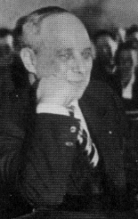  Samuel Leibowitz | Role in trial:______________________________  Background: _____________________________  Personality:______________________________  Actions: _________________________________  _________________________________________ | Similar to:
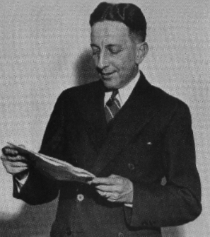  Thomas E. Knight | Role in trial:______________________________  Background: _____________________________  Personality:______________________________  Actions: _________________________________  _________________________________________ | Similar to:
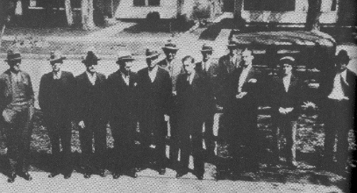  The Jury | Role in trial:______________________________  Background: _____________________________  Personality:______________________________  Actions: _________________________________  _________________________________________ | Similar to:
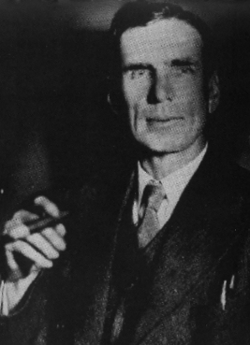  James Horton | Role in trial:______________________________  Background: _____________________________  Personality:______________________________  Actions: _________________________________  _________________________________________ | Similar to:

The Second Trial
March 30, 1933; Decatur, Alabama

Arguments for Guilt | Arguments for Innocence

Jury’s Verdict: ____________________________________________________________________

Other Notes:
_______________________________________________________________________________________________________________________________________________________________________________________________________________________________________________________________
_______________________________________________________________________________________________________________________________________________________________________________________________________________________________________________________________
_______________________________________________________________________________________________________________________________________________________________________________________________________________________________________________________________
_______________________________________________________________________________________________________________________________________________________________________________________________________________________________________________________________
_______________________________________________________________________________________________________________________________________________________________________________________________________________________________________________________________
_____________________________________________________________________________________

